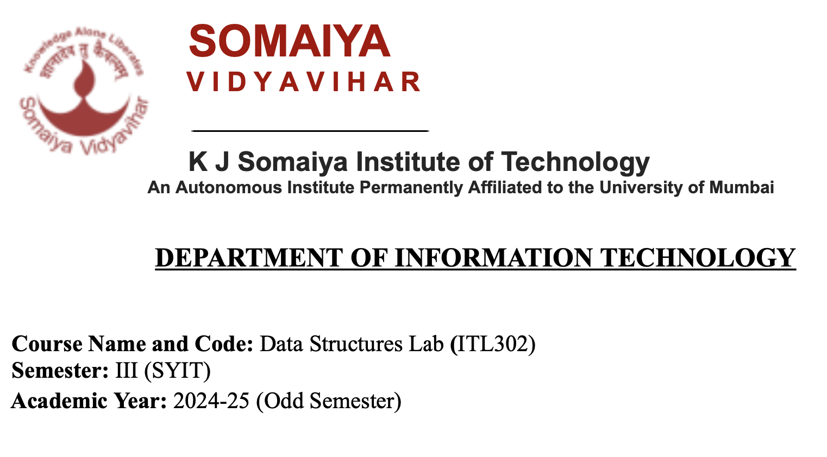

**Experiment No:9**

**Aim**:Implementation of Binary Search Technique considering a real-world application.

**Code:**

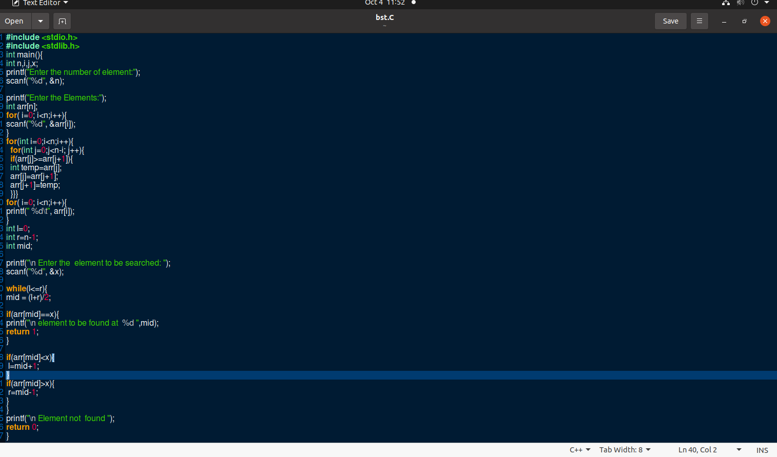

**Output:**

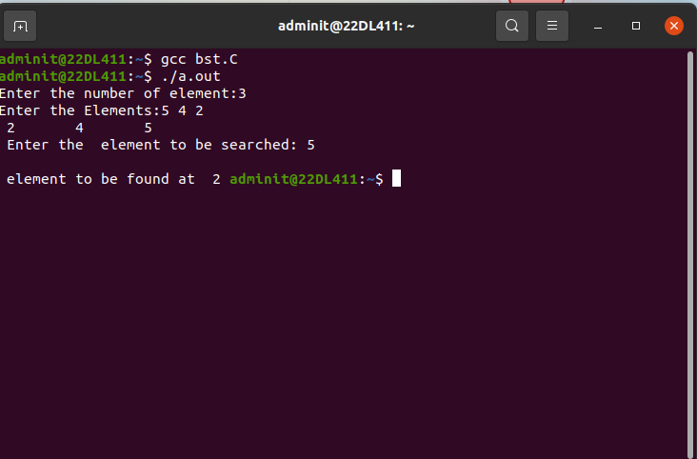

**Submitter Details -  
Name of Student: Yash.M.Dharamshi**

**Roll No.: 22  
Date of Performance: 4/10/2024**

**Date of Submission: 4/10/2024**